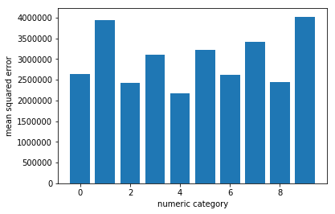

Each category errors

2629500.1004819553

3946291.224011452

2432114.02164956

3106143.4820486614

2181917.3378302944

3230258.326091132

2623435.5478147804

3424450.537289103

2438663.506102403

4024359.831349784

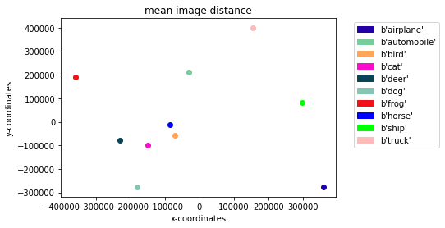

x-coord y-coord

[[ 0.51215621 -0.42662628]

[-0.04443739 0.32894098]

[-0.10092729 -0.0883715 ]

[-0.21263145 -0.1514903 ]

[-0.32848289 -0.11950559]

[-0.25576397 -0.42702635]

[-0.5117351 0.2940566 ]

[-0.1200817 -0.02058604]

[ 0.42573751 0.12823048]

[ 0.22240012 0.61567833]]

